RISHWORTH & HEATHFIELD SCHOOL SAFEGUARDING POLICY & CHILD PROTECTION PROCEDURES Addendum
COVID-19 Lockdown Arrangements

Distribution: Internal School Policy Files, Website

Note: The Designated Safeguarding lead (DSL) who takes the lead for Child Protection at Rishworth is Jessica Sheldrick (01422 822217) and at Heathfield is Anthony Wilkins (01422 823564)
The Deputy Designated Safeguarding lead at Rishworth is Diane Robinson and at Heathfield is Elisabeth Allison (01422 823564)
In addition to the above the following staff are DSL trained:
Sam Barrott and Chris Brass.
The name of the Designated Teacher for Children who are Looked After is Jessica Sheldrick (01422 822217)
The named Members of the Governing Body for Safeguarding are Dilys Whitaker and Maxine Garbett

Reference to ‘The School’ in these contexts should be taken to refer to Rishworth and Heathfield Schools as a single entity, unless specifically detailed otherwise.

ISI Policy Number : 7a (appendix)
Reviewed by: AMW / JMS
Date: Jan. 2021
Next Review: Jan. 2021

Table of contents

- Context

- Vulnerable children

- Attendance monitoring

- Designated Safeguarding Lead

- Reporting a concern

- Safeguarding training and induction

- Safer Recruitment, volunteers and movement of staff

- Online safety in school

- Children and online safety away from school

- Supporting children not in school

- Supporting children in school

- Peer on Peer abuse

- Supervision support for school safeguarding staff

Context

From 20th March 2020 and again from 5th January 2021, parents were asked to keep their children at home, wherever possible, and for schools to remain open only for those children of workers critical to the COVID-19 response - who absolutely need to attend.

Schools and all childcare providers were asked to provide care for a limited number of children - children who are vulnerable, and children whose parents are critical to the COVID-19 response and cannot be safely cared for at home.
This addendum of the Rishworth School safeguarding policy and child protection procedures contains details of our individual safeguarding arrangements in the following areas:

Vulnerable children

Vulnerable children include those who have a social worker and those children and young people up to the age of 25 with education, health and care (EHC) plans.

Those who have a social worker include children who have a Child Protection Plan and those who are looked after by the Local Authority. A child may also be deemed to be vulnerable if they have been assessed as being in need or otherwise meet the definition in section 17 of the Children Act 1989 (Child in Need)

Those with an EHC plan will be risk-assessed in consultation with the Local Authority and parents, to decide whether they need to continue to be offered a school place in order to meet their needs, or whether they can safely have their needs met at home. This could include, if necessary, carers, therapists or clinicians visiting the home to provide any essential services. Many children and young people with EHC plans can safely remain at home.

Eligibility for free school meals in and of itself should not be the determining factor in assessing vulnerability.

The Senior Leadership Team, especially the Designated Safeguarding Leads (and Deputy) know who our most vulnerable children are. They have the flexibility to offer a place to those on the edge of receiving children’s social care support.

Rishworth School will continue to work with and support children’s social workers to help protect vulnerable children. This includes working with and supporting children’s social workers and the local authority virtual school head (VSH) for looked-after and previously looked-after children. The lead person for this will be: Jessica Sheldrick

There is an expectation that vulnerable children who have a social worker will attend an education setting where the risk assessment determined they would be safer to do so. In circumstances where a parent does not want to bring their child to an education setting, and their child is considered vulnerable, the social worker and Rishworth School will explore the reasons for this directly with the parent.

Where parents are concerned about the risk of the child contracting COVID19, Rishworth School or the social worker will talk through these anxieties with the parent/carer following the advice set out by Public Health England.

Rishworth School will encourage our vulnerable children and young people to attend a school, including remotely if needed.

Attendance monitoring

From Monday 11 January, the DfE are asking schools to resume completing a revised educational setting status form.

The form is required to be submitted to the DfE by 2pm each school day.

Following the announcement of the national lockdown on 4th Jan 2021, the DfE have made changes to the educational setting status form to reflect the position on attendance of students and students due to the lockdown.
The following link provides all necessary details:
https://form.education.gov.uk/service/educational-setting-status

The information you provide through the form continues to support the government’s response to the coronavirus (COVID-19) outbreak. School data will help the DfE build a national picture of educational provision, including attendance of vulnerable children and young people and the children of critical workers in school. This will enable the DfE to focus support more effectively, help inform the government’s response and ensure children and young people are safe.

The DfE request the school provides information on:

• the number of students or students and workforce on site
• the number of students or students with a social worker or an education, health
and care plan; children of critical workers; and eligible for free school meals
• the provision for free school meals for students or students on site and those
learning remotely
• student or student absences due to coronavirus (COVID-19)
• workforce absences

Further guidance on completing the educational setting status form, and the full list of questions for schools, can be found in the guidance on recording attendance during the coronavirus (COVID-19) outbreak.
https://www.gov.uk/guidance/how-to-complete-the-educational-setting-status-form

If the school is closed for any reason other than a planned holiday (eg on public health advice due to coronavirus, for non-coronavirus reasons or a planned teacher training inset day), school will continue to complete the form.

The school is encouraged to provide information to all questions raised as this is one point of collection that the LA can access too and will reduce repetition.

Successful completion of the DfE daily information request will also help the school in accessing the workforce fund to support the cost of staff absences as explained in more detail in the following link.
https://www.gov.uk/government/publications/coronavirus-covid-19-workforce-fund-for-schools/coronavirus-covid-19-workforce-fund-to-support-schools-with-costs-of-staff-absences-from-1-november-2020-to-31-december-2020#how-schools-can-access-funding

If you have any questions that are not answered by the guidance, please call the Department for Education’s coronavirus (COVID-19) helpline on:
0800 046 8687

In addition we also provide:
Calderdale Local Authority with a weekly report of children attending the nursery, including a breakdown of students who have an EHC plan or are vulnerable.
Oldham Local Authority with a one off report to explain the provision and risk assessment for students from Oldham who have an EHC plan or are vulnerable.

Designated Safeguarding Leads

The optimal scenario is to have a trained DSL (or Deputy) available on site. Where this is not the case a trained DSL (or Deputy) will be available to be contacted via phone or online video - for example when working from home.

Where a trained DSL (or Deputy) is not on site, in addition to the above, a senior leader will assume responsibility for co-ordinating safeguarding on site.

This might include updating and managing access to child protection online management system, CPOMS (Heathfield) or iSAMS (Rishworth) and liaising with the offsite DSL (or Deputy) and as required liaising with children’s social workers where they require access to children in need and/or to carry out statutory assessments at the School.

It is important that all Rishworth School staff and volunteers have access to a trained DSL (or Deputy). On each day, the staff on site will be made aware of who that person is and how to contact them.

The DSL will continue to engage with social workers, and attend all multi-agency meetings, which can be done remotely.

Reporting a concern

Where staff have a concern about a child, they should continue to follow the process outlined in the substantive school Safeguarding Policy, this includes the recording of a report via CPOMS (Heathfield) or iSAMS (Rishworth).

In the event that a member of staff cannot access their CPOMS (Heathfield) or iSAMS (Rishworth) from home, they should email their concern/report to the Designated Safeguarding Leads or Deputy Designated Safeguarding Leads. This will ensure that the concern is received and reviewed in accordance with national safeguarding guidance.

Staff are reminded of the need to report any concern immediately and without delay.

Where staff are concerned about an adult working with children in the school, they should report their concern to the Head. If there is a requirement to make a notification to the Head whilst away from school, this should be done verbally and followed up with an email to the Head.

Concerns around the Head should be directed to the Chair of Governors: Hilary Barber.

Concerns about any adult working with children should be referred to the Local Authority Designated Officer for Child Protection (LADO)
Email: LADOAdmin@calderdale.gov.uk (This is a secure email address)

The school HR provider (the Bursar) may assist in the managing allegations process.

Safeguarding Training and induction

Designated Safeguarding Leads training remains available in Calderdale with courses running on a virtual basis whilst there remains a threat of the COVID 19 virus.

Access to courses can be secured through the Enable training platform.
A new user can register here or if already registered then simply Login here.

For the period COVID-19 measures are in place, a DSL (or Deputy) who has been trained will continue to be classed as a trained DSL (or Deputy) even if they miss their refresher training date.

All existing school staff have had safeguarding training and have read part 1 of Keeping Children Safe in Education (2020).
The DSL should communicate with staff any new local arrangements, so they know what to do if they are worried about a child.

School will continue to provide safeguarding induction training for all new staff and volunteers.

If staff are deployed from another education or children’s workforce setting to our school, we will take into account the DfE supplementary guidance on safeguarding children during the COVID-19 pandemic and will accept portability of safer recruitment checks as long as the current employer confirms in writing that:-

- the individual has been subject to an enhanced DBS and children’s barred list check

- there are no known concerns about the individual’s suitability to work with children

- there is no ongoing disciplinary investigation relating to that individual

Upon arrival, they will be given a copy of the receiving setting’s child protection policy, confirmation of local processes and confirmation of DSL arrangements.

Safer recruitment/volunteers and movement of staff

It remains essential that people who are unsuitable are not allowed to enter the children’s workforce or gain access to children. When recruiting new staff, Rishworth School will continue to follow the relevant safer recruitment processes for their setting, including, as appropriate, relevant sections in part 3 of Keeping Children Safe in Education (2020) (KCSIE).

In response to COVID-19, the Disclosure and Barring Service (DBS) has made changes to its guidance on standard and enhanced DBS ID checking to minimise the need for face-to-face contact.

If staff are deployed from another education or children’s workforce setting to our school, we will take into account the DfE supplementary guidance on safeguarding children during the COVID-19 pandemic and will accept portability as long as the current employer confirms in writing that:-

- the individual has been subject to an enhanced DBS and children’s barred list check

- there are no known concerns about the individual’s suitability to work with children

- there is no ongoing disciplinary investigation relating to that individual

Where Rishworth School are utilising volunteers, we will continue to follow the checking and risk assessment process as set out in paragraphs 167 to 172 of KCSIE. Under no circumstances will a volunteer who has not been checked be left unsupervised or allowed to work in regulated activity.

Rishworth School will continue to follow the legal duty to refer to the DBS anyone who has harmed or poses a risk of harm to a child or vulnerable adult. Full details can be found at paragraph 179 and 262 of KCSIE 2020.

Rishworth School will continue to consider and make referrals to the Teaching Regulation Agency (TRA) as per paragraph 261 of KCSIE 2020 and the TRA’s ‘Teacher misconduct advice for making a referral.

During the COVID-19 period all referrals should be made by emailing Misconduct.Teacher@education.gov.uk

Whilst acknowledging the challenge of the current National emergency, it is essential from a safeguarding perspective that any school is aware, on any given day, which staff/volunteers will be in the school, and that appropriate checks have been carried out, especially for anyone engaging in regulated activity. As such, Rishworth School will continue to keep the single central record (SCR) up to date as outlined in paragraphs 164 to 171 in KCSIE 2020.

Online safety in schools

Rishworth School will continue to provide a safe environment, including online. This includes the use of an online filtering system.

Where students are using computers in school, appropriate supervision will be in place. This supervision may include the use of electronic monitoring systems that alert school leaders to inappropriate use of computer related equipment.

Staff and students will be expected to follow the school’s online safety policy.

Children and online safety away from school

It is important that all staff who interact with children, including online, continue to look out for signs a child may be at risk. Any such concerns should be dealt with as per the Child Protection Policy and where appropriate referrals should still be made to children’s social care and as required, the police.

Online teaching should follow the same principles as set out in out in the school/MAT code conduct.

Rishworth School will ensure any use of online learning tools and systems is in line with privacy and data protection/GDPR requirements.

Below are some things to consider when delivering virtual lessons, especially where webcams are involved:

- No 1:1s, groups only (please note 1:1’s can go ahead where the parent is present with the student at the time)
- Staff and children must wear suitable clothing, as should anyone else in the household.
- Any computers used should be in appropriate areas, for example, not in bedrooms; and the background should be blurred.
- The live class should be recorded so that if any issues were to arise, the video can be reviewed.
- Live classes should be kept to a reasonable length of time, or the streaming may prevent the family ‘getting on’ with their day.
- Language must be professional and appropriate, including any family members in the background.
- Staff must only use platforms specified by senior managers and approved by our IT network manager / provider to communicate with students
- Staff should record, the length, time, date and attendance of any sessions held.

Supporting children not in school

Rishworth School is committed to ensuring the safety and wellbeing of all its children and young people.

Where the DSL has identified a child to be on the edge of social care support, or who would normally receive pastoral-type support in school, we will try and ensure that a robust communication plan is in place for that child or young person.

Details of this communication plan will be recorded on CPOMS (Heathfield) or iSAMS (Rishworth) as should a record of contacts that have made.

The communication plans can include; remote contact, phone contact, text contact. Other alternative individualised contact methods should be considered and recorded.

Rishworth School and its DSL will work closely with all stakeholders to maximise the effectiveness of any communication plan.

It is recommended that in the main, vulnerable students are contacted twice weekly unless additional measures become necessary which will be agreed in conjunction with a social worker.

This plan will be reviewed regularly (at least once a fortnight) and where concerns arise, the DSL will consider whether any referrals to MAST or other agencies for support may be necessary.

Where school cannot establish contact with vulnerable students and their families, it is important to ensure this situation is passed to the MAST team using email address: MASTAdmin@calderdale.gov.uk

The school will share safeguarding messages on its website and social media pages.

Rishworth School recognises that school is a protective factor for children and young people, and the current circumstances, can affect the mental health of students and their parents/carers. Teachers at Rishworth School need to be aware of this in setting expectations of students’ work where they are at home.

Supporting children in school

Rishworth School is committed to ensuring the safety and wellbeing of all its students.

Rishworth School will continue to be a safe space for all children to attend and flourish. The Head will ensure that appropriate staff are on site and staff to student ratio numbers are appropriate, to maximise safety.

Rishworth School will refer to the latest Government guidance for education and childcare settings on how to implement social distancing and continue to follow the advice from Public Health England on handwashing and other measures to limit the risk of spread of COVID19.

Rishworth School will ensure that where we care for children of critical workers and vulnerable children on site, we ensure appropriate support is in place for them. This will be bespoke to each child and recorded on CPOMS (Heathfield) or iSAMS (Rishworth).

Where it is necessary to provide personal and/or intimate care in respect of a child, school will follow their substantive personal and intimate care policy including making a record of the nature/time/date and staff involved in respect of care provided.

School leaders will monitor the impact of any staff absence, in particular the posts of Designated Safeguarding Leads and first aid trained staff in order to ensure the safe and effective running of the school and take appropriate management action where necessary.

Peer on Peer Abuse

Rishworth School recognises that during the closure a revised process may be required for managing any report of peer on peer abuse and supporting victims.

Where a school receives a report of peer on peer abuse, they will follow the principles as set out in part 5 of KCSIE 2020 and of those outlined within the substantive school safeguarding policy.

The school will listen and work with the young person, parents/carers and any multi-agency partner required to ensure the safety and security of that young person.

Concerns and actions must be recorded on CPOMS (Heathfield) or iSAMS (Rishworth)and following assessment by the Designated Safeguarding Lead, appropriate referrals made.

Supervision Support for the school safeguarding staff

Governors and Trustees of the school should ensure that appropriate supervision support is in place for staff engaged in the safeguarding process, in order to carry out their role effectively.

This may include, remotely accessing child safeguarding files for the purpose of quality assurance, support, guidance and direction.

Regular group and individual safeguarding supervision sessions should remain a key factor in ensuring the effectiveness of safeguarding at the school.

Appendix 1

Child Protection
Cause for Concern Form

Date: |  | Time:
Name of Child:
Date of Birth:
Reporting Adult: |  | Role:
Reporting Adult Signature: |  | DSL Signature:

Details of Concern (who, what, where, when):

Facts -

Opinions -

DSL Follow up:

Early Intervention Service Manager Contacted for advice Yes/No

Early Intervention Panel Referral Yes/No

MAST Contacted for advice: Yes/No

MAST Referral: Yes/No

Time of contact:

Outcome of contact:

Child’s CASS Number:

Actions:

Review Date:

Appendix 2

Body Map Guidance for Schools

Body Maps should be used to document and illustrate visible signs of harm and physical injuries.

Always use a black pen (never a pencil) and do not use correction fluid or any other eraser.

Do not remove clothing for the purpose of the examination unless the injury site is freely available because of treatment.

*At no time should an individual teacher/member of staff or school take photographic evidence of any injuries or marks to a child’s person, the body map below should be used. Any concerns should be reported and recorded without delay to the appropriate safeguarding services, e.g. MAST or the child’s social worker if already an open case to social care.

When you notice an injury to a child, try to record the following information in respect of each mark identified e.g. red areas, swelling, bruising, cuts, lacerations and wounds, scalds and burns:

- Exact site of injury on the body, e.g. upper outer arm/left cheek.
- Size of injury - in appropriate centimetres or inches.
- Approximate shape of injury, e.g. round/square or straight line.
- Colour of injury - if more than one colour, say so.
- Is the skin broken?
- Is there any swelling at the site of the injury, or elsewhere?
- Is there a scab/any blistering/any bleeding?
- Is the injury clean or is there grit/fluff etc.?
- Is mobility restricted as a result of the injury?
- Does the site of the injury feel hot?
- Does the child feel hot?
- Does the child feel pain?
- Has the child’s body shape changed/are they holding themselves differently?

Importantly the date and time of the recording must be stated as well as the name and designation of the person making the record. Add any further comments as required.

Ensure First Aid is provided where required and then recorded appropriately.

A copy of the body map should be kept on the child’s concern/confidential file.

BODYMAP
(This must be completed at time of observation)

Name of Student: |  |  |  | Date of Birth:
Name of Staff: |  |  |  | Job title:
Date and time of observation:
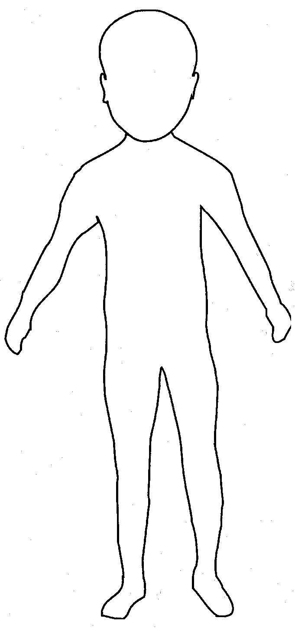 |  |  | 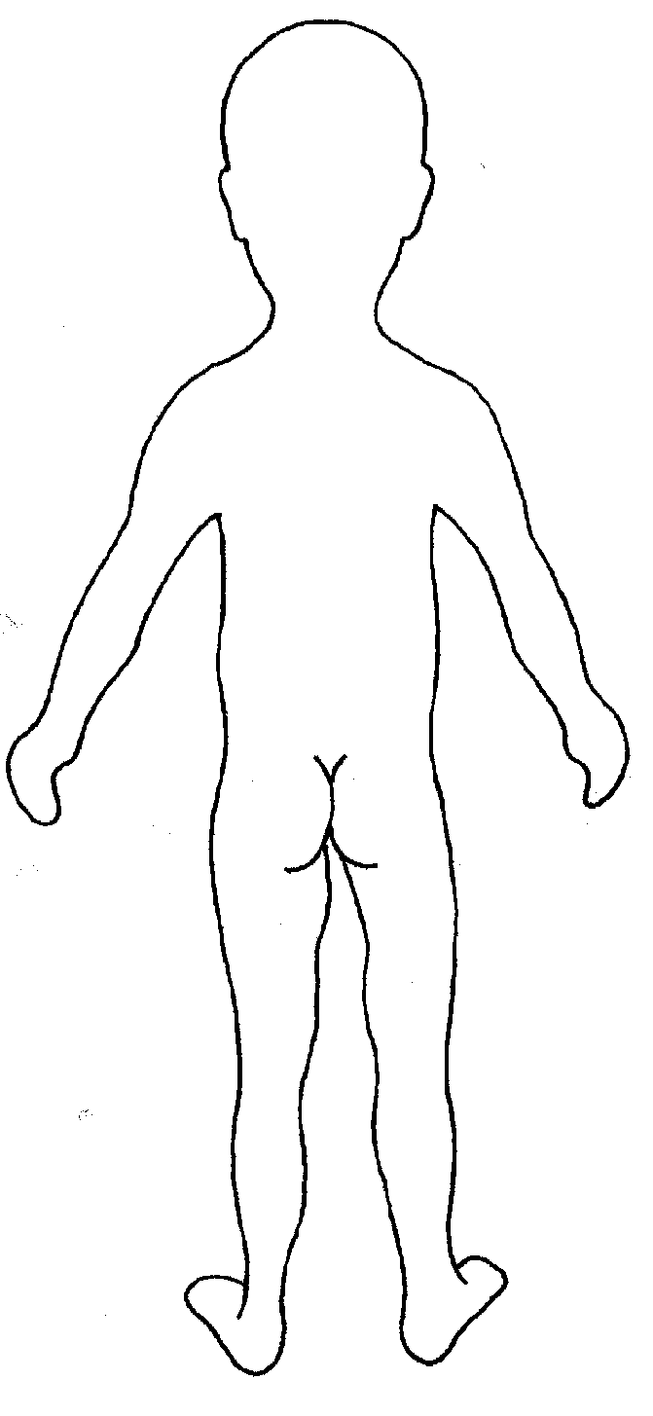

Name of student: |  |  | Date and time of observation:
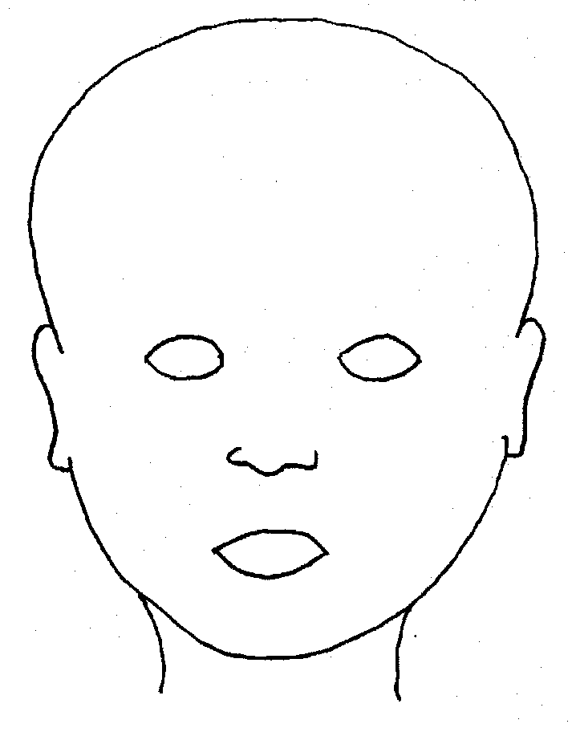
FRONT |  | BACK
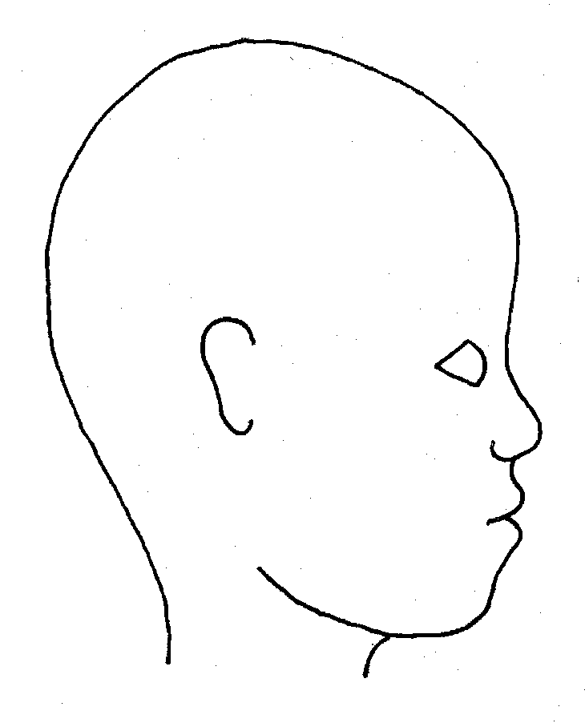 |  | 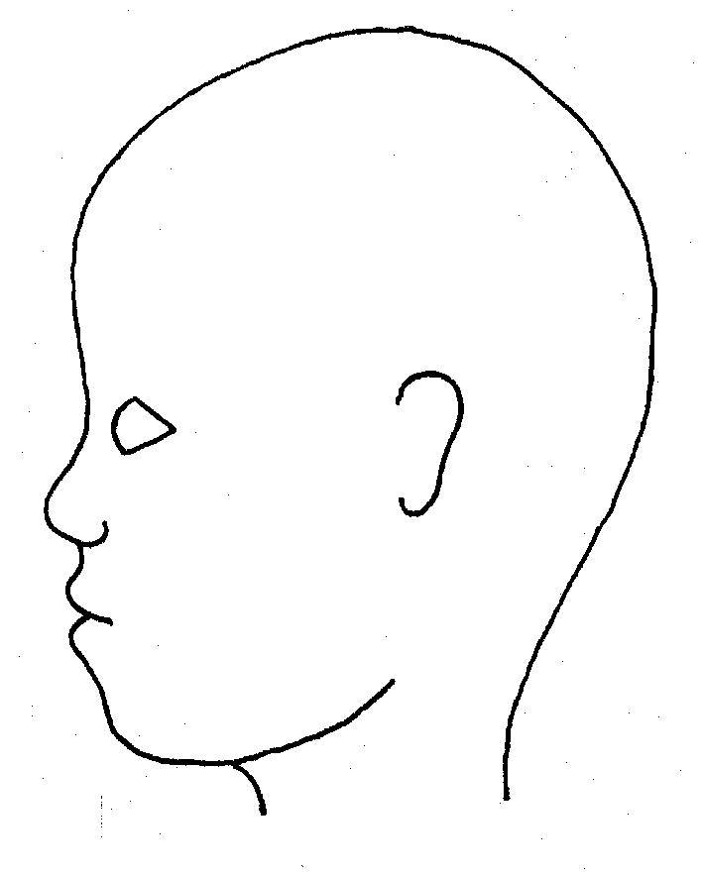
RIGHT |  | LEFT

Name of student: |  |  |  |  |  |  | Date and time of observation:
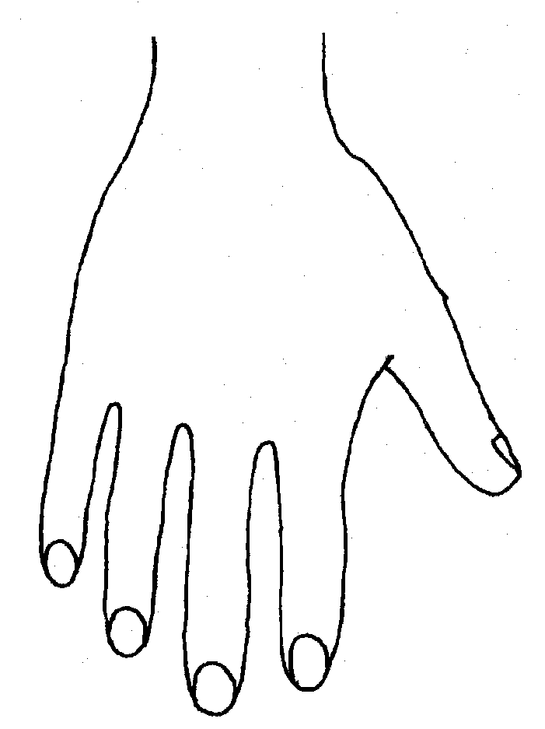 |  |  |  |  |  | 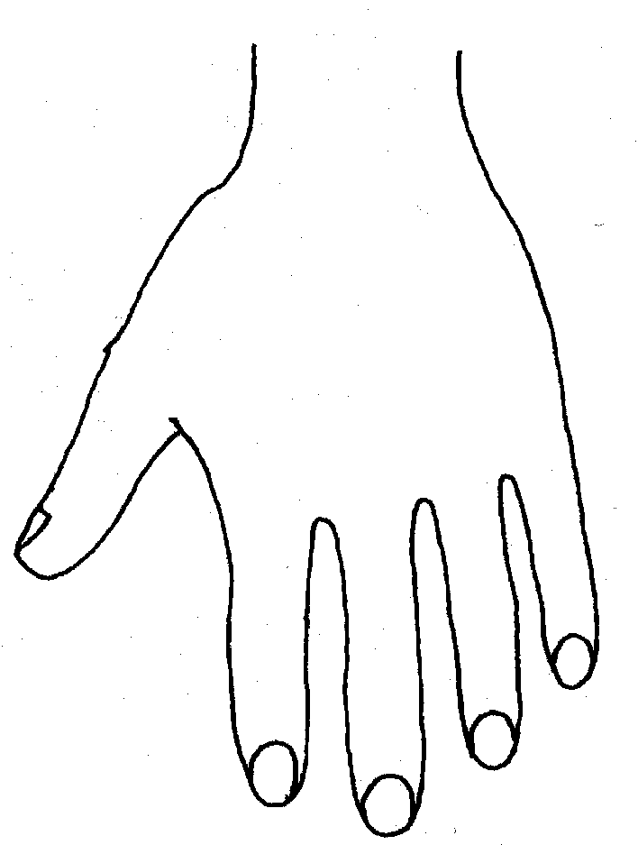
R |  |  |  |  |  | L
BACK
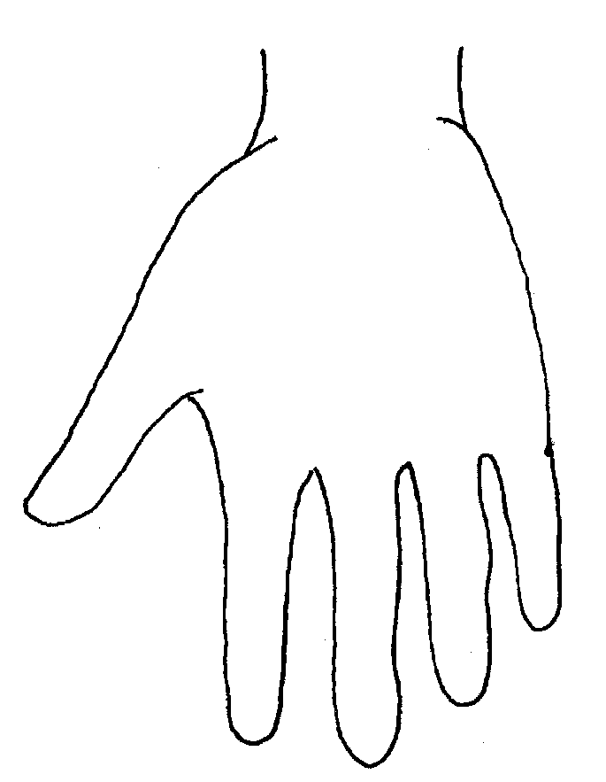 |  |  |  |  |  | 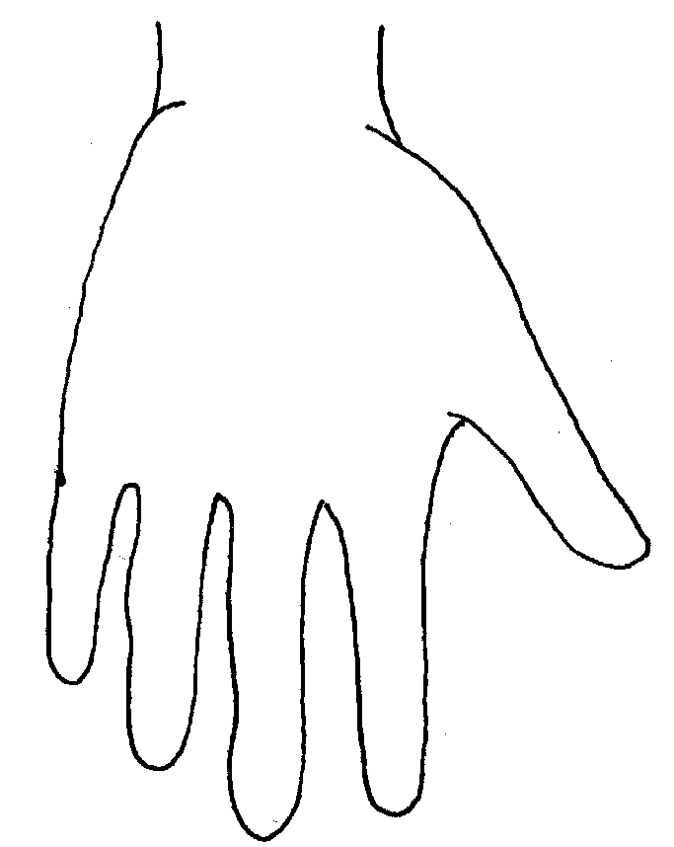
FRONT
Name of Student: |  |  |  |  |  |  | Date and time of observation:
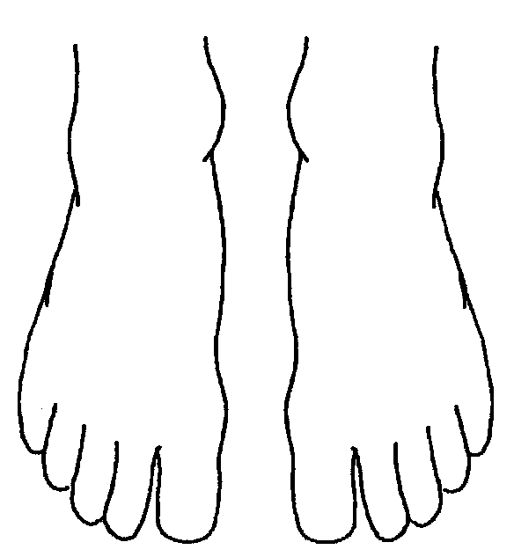 |  |  |  |  | 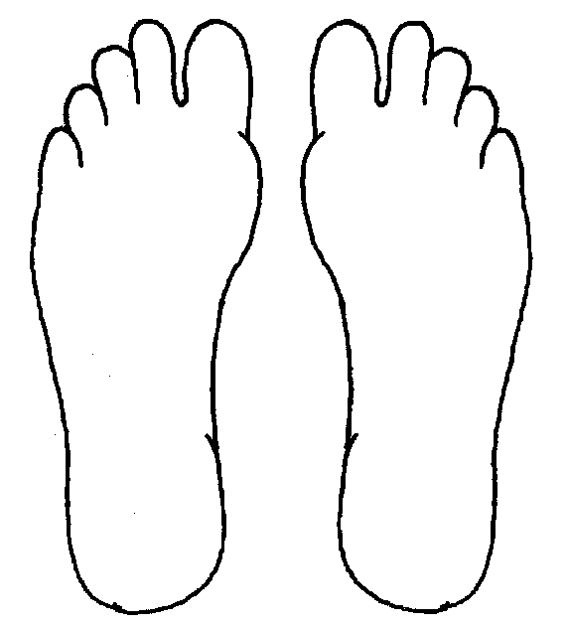
R |  | TOP | L |  | R |  |  | BOTTOM |  | L
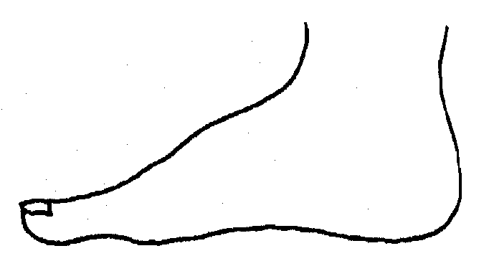
R |  |  |  |  | L
INNER
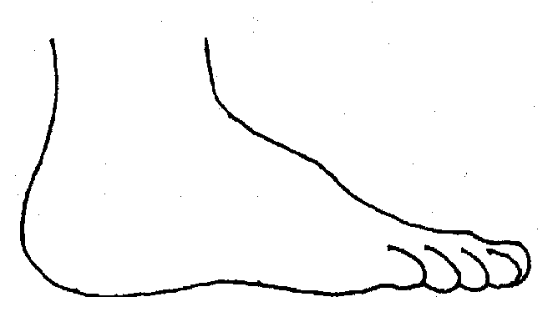 |  |  |  |  | 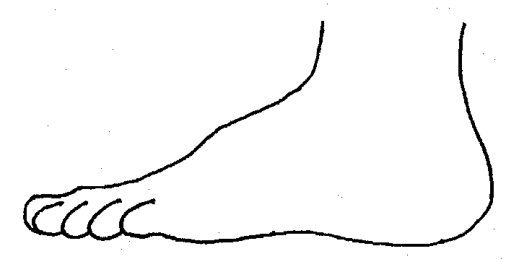
R |  |  |  |  | L
OUTER
Name:

Signature:
Job title of staff:

