ISI Policy Number : 10a
Reviewed by: JMS
Date: Mich. 2020
Next Review: Mich. 2021

BULLYING POLICY
Distribution: Issued to parents and pupils (including boarders) via The Parents’ and Pupils’ Handbook and website. Available to staff via same and via School’s Internal Policy Files.
- Preamble
- This policy forms part of a series of policies whose purpose is to promote and protect pupils’ welfare throughout their education at Rishworth. These policies, which should be read in conjunction with this policy, are those relating to
- Child Protection and Safeguarding,
- Health and Safety,
- Health and Safety of Pupils on School Visits and
- Promoting Good Behaviour, Discipline and Sanctions.
- The keynote of all these policies is that pupils will learn best in a safe and calm environment that is free from disruption and in which education is the primary focus.
- Principles
- Rishworth School will not accept bullying in any of its forms. This policy exists to help prevent and combat bullying, promote welfare and allow all members of the school community to live as one together. Prevention of bullying comes first, followed by swift intervention to deal with any incidents that do occur.
- What is meant by bullying?
- Bullying may be understood as the persistent or systematic use of superior strength or influence to intimidate another person (or persons) such that the repeated treatment received by that person (or persons) from the other (or others) causes, or is likely or intended to cause, hurt or harm. Such hurt or harm includes the physical, sexual, psychological and social (for example besmirching a person’s reputation or attacking someone, overtly or covertly, based on race, gender or sexual orientation).
- It follows that bullying can take many forms besides the physical, including verbal, gestural, taking property belonging to another, and ‘cyber’ (the misuse of technology, e.g. texts / sexting, mobile phones, emails and the internet, including social networking sites, films and photographs), and can involve extortion, humiliation, spreading rumours and exclusion.
- The intimidating treatment of a person on the basis of that person’s attachment to (or supposed attachment to) a particular group or sub-group or prejudice of those with a protected characteristic is unacceptable. Such groups and sub-groups can be based, for instance, on sexual orientation, race, age, gender / transgender, colour, culture, religion, other beliefs, socio-economic background, SEN, disability, or physical appearance. These groups and sub-groups may be particularly vulnerable.
- The list of such sub-groups is virtually limitless, however; it is the principle of ostracism by identification with sub-groupings (perhaps best understood through the concept enshrined in the Japanese language and culture of ‘in-groups’ and ‘out-groups’) that is unacceptable.
- Whatever form bullying takes, it is the effect on its victim, which can be devastating, leading to psychological harm and even suicide, that is the main concern. Even words, gestures or actions not intended to cause hurt sometimes can. On this point the School recognises, and tries to educate pupils about, the fine line that sometimes exists between what one party may regard as ‘harmless teasing’, ‘banter’, a ‘joke’ or a ‘prank’ and what another may feel is genuinely hurtful and perceive as bullying, such as initiation ceremonies that might cause pain, anxiety or humiliation.
- Bullying becomes a child protection concern where peer on peer abuse becomes more than a behaviour management issue and a child is at potential risk of significant harm and where indicators of harm are evident within the child as would be seen in any other abusive situation, for example, where a child may be abused by an adult, and as outlined within the Child Protection Policy.
- There is no ‘hierarchy’ of bullying - all forms of bullying should be treated seriously and dealt with appropriately. Although bullying is not a specific criminal offence, there are laws that make it a criminal offence to assault, harass or threaten others.
- Policy Aims
- To create an environment that prevents bullying being a serious problem in the first place.
- To prevent and/or deal with any behaviour that might constitute bullying by promoting an understanding and environment that activities that might be described as ‘banter’ or ‘part of growing up’ are not used to excuse bad or abusive behaviour.
- To promote an awareness of the need to ensure everyone is entitled to live in the school community free from intimidation.
- To understand and be vigilant to the fact that boarding students are potentially more vulnerable with regard to bullying or peer on peer abuse particularly where relationships can develop between students and where there may be a gender imbalance. Our aim is to build a secure framework around boarding pupils to ensure that they feel supported and able to speak to any staff but particularly House Staff about any concerns that they have.
- To respond to any incident of bullying in a reasonable, proportionate and consistent manner.
- To safeguard and provide appropriate support to any pupil who has been the victim of bullying.
- To apply measures (including disciplinary sanctions, in accordance with the School’s Promoting Good Behaviour, Discipline and Sanctions Policy), to any pupil who is found to be responsible for bullying, in addition to providing them with appropriate help and guidance and to learn how they can take steps to repair the harm they have caused. As the School’s Promoting Good Behaviour, Discipline and Sanctions Policy makes clear, it is unwise to equate an offence, in abstraction, with a given sanction, as each case must be considered on its own terms. None the less, it should be noted that strong sanctions, including exclusion, may be appropriate in cases of severe and persistent bullying.
- Strategies
- To create an ethos of good behaviour where pupils treat one another and staff with respect because they know this is the right way to behave.
- To promote a climate of openness (a) in which it is widely perceived as ‘right’ to report any instance of anyone being treated improperly by anyone else, (b) in which bullying specifically is understood to be unacceptable, and (c) which works on the twin principles that bullying thrives on secrecy and prevention is better than cure.
- To ensure that a clear and effective reporting system exists for dealing with bullying and suspected bullying of which staff, pupils and parents are aware and to ensure that all staff are particularly vigilant with regard to peer on peer bullying within the boarding context where pupils are more vulnerable through the fact that they reside away from home.
- To help prevent bullying by providing opportunities for discussion by pupils and staff within the school’s PSHCE and pastoral programmes, as well as through subjects’ curricular openings (e.g. through empathy work in History and English) and assemblies. Particular effort is made through the PSHCE programme to promote tolerance and respect towards all, but with particular attention towards prejudice of those with protected characteristics (see 3.3). The PSHCE programmes are available to all staff within the Staff Work Room and on the public drive.
- To make sure staff are well placed to administer the policy by incorporating anti-bullying as part of the induction of new staff and ensure that appropriate training is provided for all staff through the INSET programme.
- To recognise that there are times and places in schools where bullying is most likely to occur and to implement effective procedures to combat bullying at these times and places. The School identifies the most likely times and places for bullying to occur as:
- from 8.00 – 8.30 am in the indoor day areas (from 7.45 am at Heathfield)
- morning breaks in the outdoor play areas
- lunchtimes in the outdoor play areas and the indoor day areas
- morning breaks and lunchtimes in the pupils’ toilets
- additionally, for boarders, out of day-school hours in the boarding houses and the boarders’ social areas
- when travelling to and from school by bus
Supervision (including patrols by staff and prefects) allows for the regular monitoring of all of these areas at the times when pupils use them. Pupils travelling by bus are monitored by sixth form students.
- To ensure, through vigilance and the education of pupils, that there are no ‘initiation ceremonies’.
- To ensure that pupils are aware of the Anti-Bullying Policy in particular through the information sheet for pupils (a copy of which is in every student’s planner)
- To ensure that pupils are aware of the standards and expectations set by the School’s Student Acceptable ICT Use Policy (a copy of which is in every student’s planner) regarding cyber activities (as defined above).
- To provide opportunities for continuing professional development to staff, via Inset and other means, regarding their roles and responsibilities in preventing and responding to bullying.
- To ensure that all pupils have access at all times to an adult in school to whom they may talk in confidence and know that that adult will deal with the matter urgently and with discretion. It is particularly important that pupils who board know that they have an outlet to speak to an adult (hopefully their tutors in the first instance) as they are potentially more vulnerable to bullying or mistreatment through the nature of boarding and being away from their family.
- To make pupils aware of helplines, and that such numbers are prominently displayed in and around the School.
- To follow up every incident of bullying so as (a) to take any initial precautionary steps to ensure that a pupil who says (s)he has been bullied feels protected and reassured (b) to establish by investigation those facts which are knowable (c) to provide every possible support for the victim and perpetrators, where bullying has indeed taken place (d) to ensure that false allegations are identified as such and dealt with appropriately and (e) to help prevent any recurrence of bullying where it has occurred.
- To make clear to pupils and parents that bullying is unacceptable and that the School will not tolerate such behaviour whether it has occurred within our outside of ‘School’ e.g. via social media. The point is that if a member of our community is being bullied by another member of our community the matter must be addressed.
- To review and update (as necessary) this policy and its procedures biennially and to circulate a copy of any updated version of it to staff
- To be aware that although bullying itself is not a specific criminal offence, it is important to bear in mind that some types of harassing or threatening behaviour – or communications – can amount to a criminal offence: for instance, under the Protection from Harassment Act 1997, the Malicious Communications Act 1988, the Communications Act 2003 and the Public Order Act 1986. The School may seek assistance from the police in appropriate circumstances.
- To involve parents and guardians by making a copy of this policy available via The Parents’ and Pupils’ Handbook and via the school’s website.
- Procedure
- Tutors must inform all new pupils of the staff to whom they can talk to in confidence about bullying e.g. Tutor, Head of School Section, Housemaster, Matron.
- Any incident of possible bullying must be acted on by the member of staff who has witnessed it or to whom it is reported. Incidents may be reported from a variety of sources, parents, prefects, pupils and teaching, administrative or ancillary staff.
- Administrative and ancillary staff who receive a report of suspected bullying from a pupil or a parent must inform a Deputy Head immediately, or, in their absence the Head or other member of senior staff.
- In every case involving an incident of possible bullying, (a) consideration should be given to what immediate, precautionary steps might be taken to help the pupil feel safe and secure (b) the pupil’s tutor must be informed, and (c) the Tutor must inform the Head of School Section and, in the case of a boarder, his or her Housemaster or Housemistress.
- Following a report of possible bullying a suitable member of staff, such as the Tutor and/or the Head of School Section (and the Housemaster or Housemistress and/or Assistant Housemaster/Housemistress in the case of a boarder) will investigate the incident in order to check the facts and assess its seriousness. If the incident constitutes bullying, the member of staff will decide how best to proceed: different solutions are needed for different pupils. Consideration will be given, amongst others, to the following issues:
- whether or not to contact parents, and at what stage
- if punishment is necessary, what sanction should be imposed
- if the victim (or perpetrator) needs guidance, what advice will be appropriate (e.g. for the victim, tips for reducing hypersensitivity, for controlling overreaction, for avoiding potentially fraught situations, for managing verbal exchanges, for avoiding escalation etc; for the perpetrator, tips for understanding others’ feelings and viewpoints, for increasing self-awareness of motivation, for behaving within stipulated guidelines etc)
- what, if any, follow-up work is required, and by whom it will be undertaken
- Written records of every investigation and any communication with parents should be kept in the pupil’s file.
- The school keeps a central log of allegations and/or incidents of bullying to help any patterns to be identified and for internal review purposes and inspection, as required by the Head and Chair of Governors.

See also:
Rishworth and Heathfield School Safeguarding Policy (with particular reference to peer-on-peer abuse)
Rishworth and Heathfield Child Protection Procedures
Appendix A: Anti-bullying information sheet for pupils (Heathfield version)
Appendix B: Anti-bullying information sheet for pupils
Appendix C: Our own Anti-bullying poster derived from our Policy

References:
DfE Preventing and tackling bullying Advice for Headteachers, staff and governing bodies (October 2014)
The Education Independent School Standards (England) Regulations (April 2015 (Part 3 (10))
Boarding Schools: National Minimum Standards (April 2015) (Standard 12)
The Equality Act 2010
The Children Act 1989
Appendix A: Heathfield Anti-Bullying Policy

- Is it bullying?
It is bullying if you feel hurt because of things said about your ethnic background, religious faith, gender, sexuality, disability, special educational need, appearance or issues in your family. It is bullying if you feel hurt because individuals or groups are:

- calling you names
- threatening you
- pressuring you to give someone money or possessions
- hitting you
- damaging your possessions
- spreading rumours about you or your family
- using text, email or web space to write or say hurtful things (cyberbullying).

We do not tolerate bullying at Heathfield. This is what we do about bullying:

- train teaching staff, non-teaching staff and prefects to identify and deal with incidents of bullying
- through lessons and assemblies, make pupils aware of what is acceptable and what is unacceptable behaviour
- make sure that any person being bullied is safe
- work to stop the bullying happening again
- provide support to the person being bullied.

2 What should you do?
Talk to someone you trust and get them to help you take the right steps to stop the bullying. If you feel you are being bullied:

- try to stay calm and look as confident as you can
- be firm and clear — look them in the eye and tell them to stop
- get away from the situation as quickly as possible
- tell an adult what has happened straight away or, if you do not feel comfortable telling an adult, tell another pupil.

If you have been bullied:

- tell a teacher or another adult
- tell your family
- go to the drop-in
- if you are scared to tell a teacher or an adult on your own, ask a friend to go with you
- keep on speaking until someone listens and does something to stop the bullying
- don't blame yourself for what has happened.

When you are talking to an adult about bullying be clear about:

- what has happened to you
- how often it has happened
- who was involved
- who saw what was happening
- where it happened
- what you have done about it already.

If you find it difficult to talk to anyone at school or at home, ring ChildLine on freephone 0800 1111. This is a confidential helpline.

3 Bullying thrives in a climate of secrecy.
- Tell someone if ever you feel you have been subjected to hurtful treatment or words.
- Tell someone if ever you witness someone else being subjected to hurtful treatment or words.
- This is not ‘sneaking’. It’s not ‘grassing’. It’s being a responsible member of a caring community.
- If you do not tell someone who is in a position to help, the problem is unlikely to go away.
- If you do tell someone, you put the School in a position to do something to help.
… Also, the bully’s cover is blown - they are exposed and have nowhere to hide. So you help stop recurrences of bullying - in your own regard and generally.

Is it bullying?
Appendix B: Anti-bullying information sheet for pupils (Years 7 -13)

It is bullying if you feel hurt because of things said about your ethnic background, religious faith, gender, sexuality, disability, special educational need, appearance or issues in your family. It is bullying if you feel hurt because individuals or groups are:
- calling you names
- threatening you
- pressuring you to give someone money or possessions
- hitting you
- damaging your possessions
- spreading rumours about you or your family
- using text, email or web space to write or say hurtful things (cyberbullying).
We do not tolerate bullying at Rishworth School. This is what we do about bullying:
- train teaching staff, non-teaching staff and prefects to identify and deal with incidents of bullying
- through lessons and assemblies, make pupils aware of what is acceptable and what is unacceptable behaviour
- make sure that any person being bullied is safe
- work to stop the bullying happening again
- provide support to the person being bullied.

What should you do?
Talk to someone you trust and get them to help you take the right steps to stop the bullying. If you feel you are being bullied:
- try to stay calm and look as confident as you can
- be firm and clear— look them in the eye and tell them to stop
- get away from the situation as quickly as possible
- tell an adult what has happened straight away or, if you do not feel comfortable telling an adult, tell another pupil.

If you have been bullied:
- tell a teacher, another adult or a prefect in School
- tell your family
- if you are scared to tell a teacher or an adult on your own, ask a friend to go with you
- keep on speaking until someone listens and does something to stop the bullying
- don't blame yourself for what has happened.

When you are talking to an adult about bullying be clear about:
- what has happened to you
- how often it has happened
- who was involved
- who saw what was happening
- where it happened
- what you have done about it already.
Bullying thrives in a climate of secrecy
- Tell someone if ever you feel you have been subjected to hurtful treatment or words.
- Tell someone if ever you witness someone else being subjected to hurtful treatment or words.
- This is not 'sneaking'. It is not 'grassing'. It's being a responsible member of a caring community.
- If you do not tell someone who is in a position to help, the problem is unlikely to go away.
- If you do tell someone, you put the School in a position to do something to help.
.., Also, the bully's cover is blown - they are exposed and have nowhere to hide. So you help stop recurrences of bullying - in your own regard and generally.
If you find it difficult to talk to anyone at school or at home, ring ChildLine on freephone 0800 1111. This is a confidential helpline.

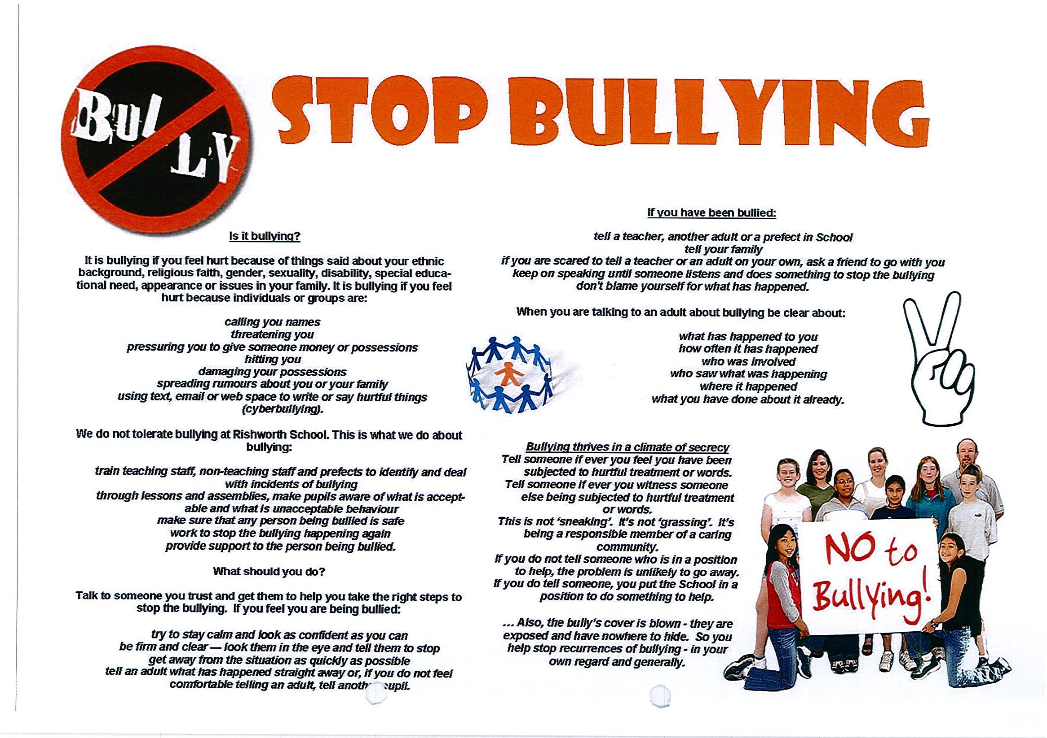
Appendix C

